As the change in X of the secant line approaches 0, it appears to be tangent with the function at the point a

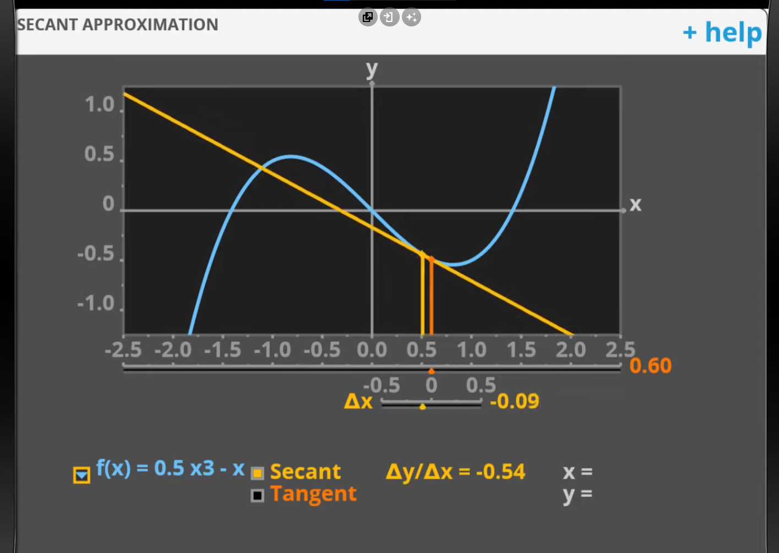

Plotting the tangent line, when moving closer to point a (change in x becomes 0)

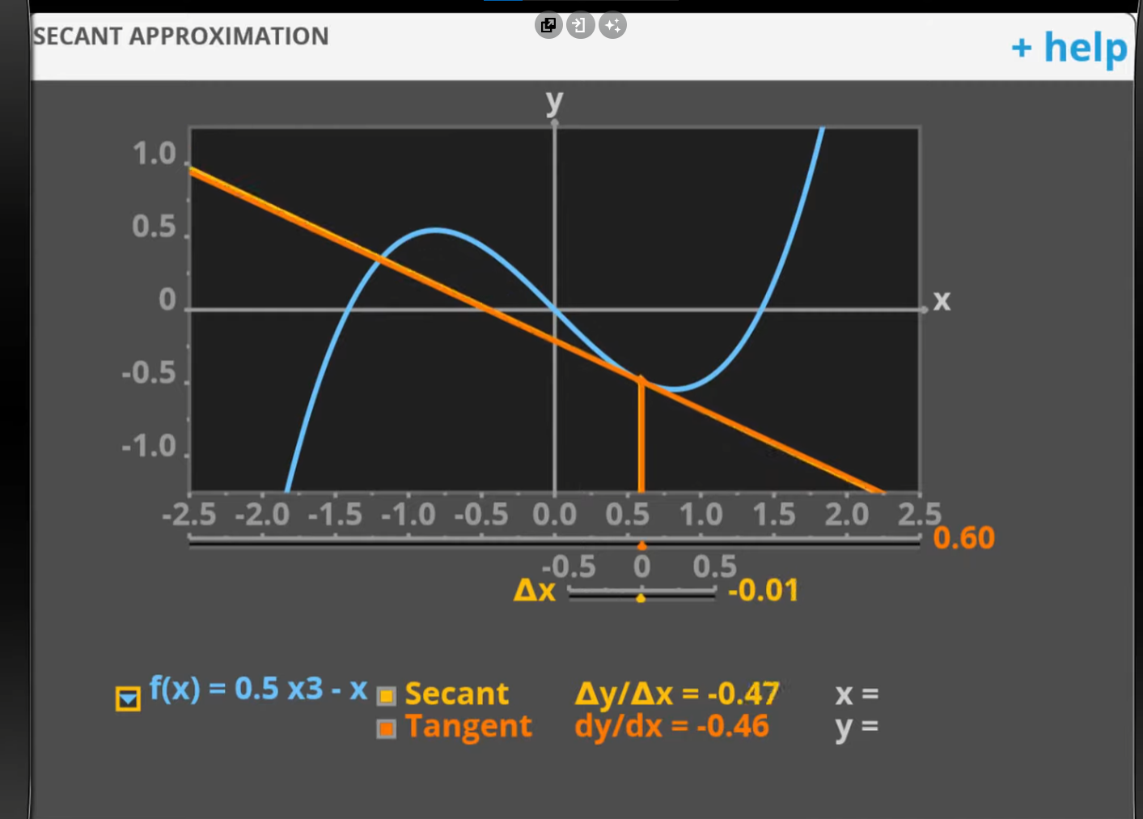

* The secant also becomes the tangent line

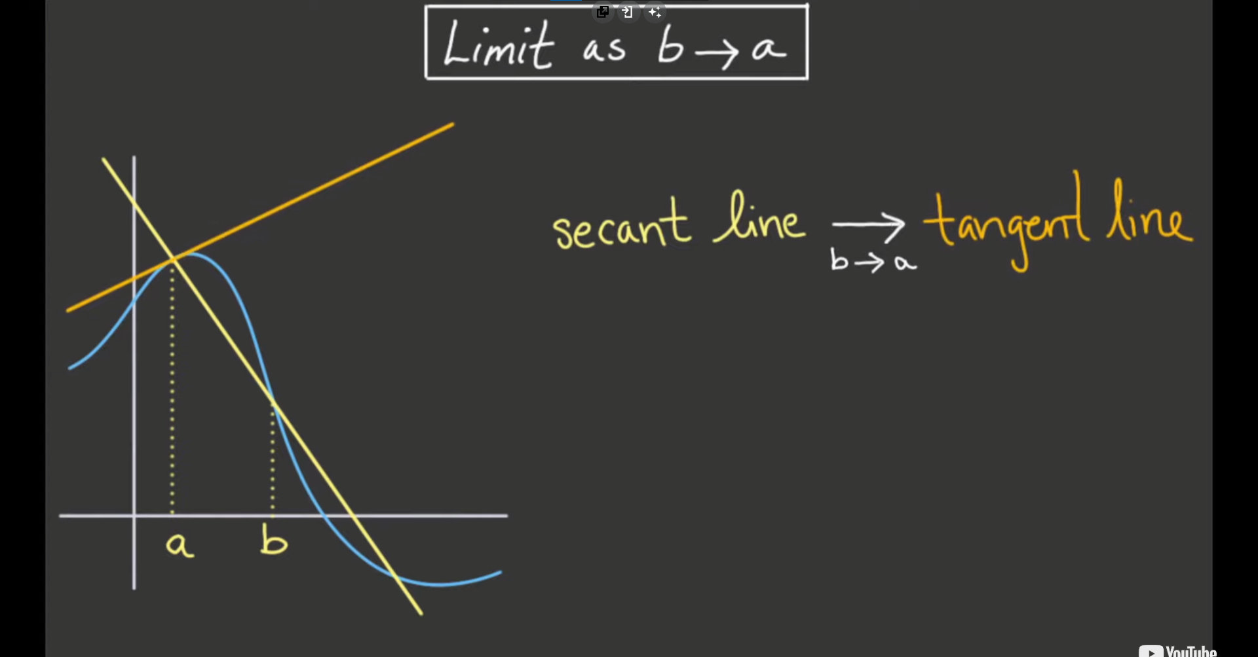

* As b approaches a, the secant line approaches the tangent line

